|  |  |
| --- | --- |
|  | **YEAR 12 MATHEMATICS SPECIALIST**  **SEMESTER ONE 2016**  **TEST 2: Functions** |

Name: _______________________

Friday 1st April

**Time: 50 minutes Mark /45 = %**

* Answer all questions neatly in the spaces provided. **Show all working.**
* You are permitted to use the Formula Sheet in **both** sections of the test.
* You are permitted one A4 page (one side) of notes in the calculator assumed section.

**Calculator free section Suggested time: 30 minutes /28**

1. [11 marks]

Two functions *f* and *g* are defined by  and 

* 1. Evaluate 





[2]

* 1. What is the range of  when ?



[1]

* 1. What is the natural domain of 





[2]

* 1. Predict the domain and range for 

Domain: 

Range: 

[2]

* 1. Determine , including all domain restrictions

 

for 

[2]

Turn over for the last part of question 1

* 1. Sketch  and clearly indicate the range of this composite function. [2]

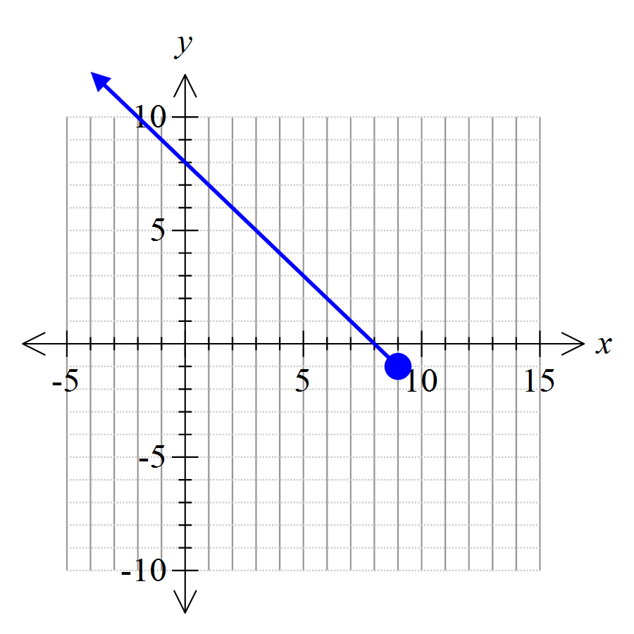

Range: 

1. [17 marks]

Consider the rational function 

* 1. Identify and classify all points of discontinuity

[4]

 provided 

Vertical/infinite discontinuity at 

(Singular) point discontinuity at 

* 1. List the asymptotes (horizontal and vertical)

[2]

 (vertical)

 (horizontal, from  )

* 1. Determine all intercepts

[2]

 is the only intercept

* 1. Sketch  [3]

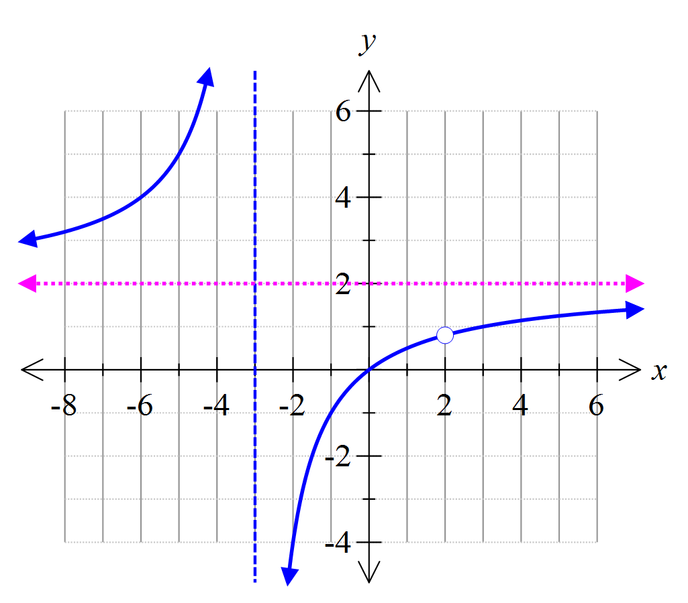

* 1. Does  possess an inverse function ? How do you know?

[2]

Yes; it is a 1 to 1 function over the domain 

(passes horizontal line test)

* 1. Show algebraically that  and identify appropriate restrictions on the domain and range.  
     Use a simplified expression for  in your calculations.

[4]

 has an inverse defined by 









Domain restrictions: 

Range restrictions: 

**Calculator assumed section Suggested time: 20 minutes /17**

Name: _______________________

1. [5 marks]

Mark solutions to these equations on the number lines provided.

In (b), clearly explain clearly how to use distance considerations in determining the solution.

* 1. 

[1]



* 1. 

Sum of the distance of *x* from ­3 plus distance from 1 should be 4



[3]

* 1. 



[1]

1. [5 marks]

The graph of  is shown. Add the graphs of  and .

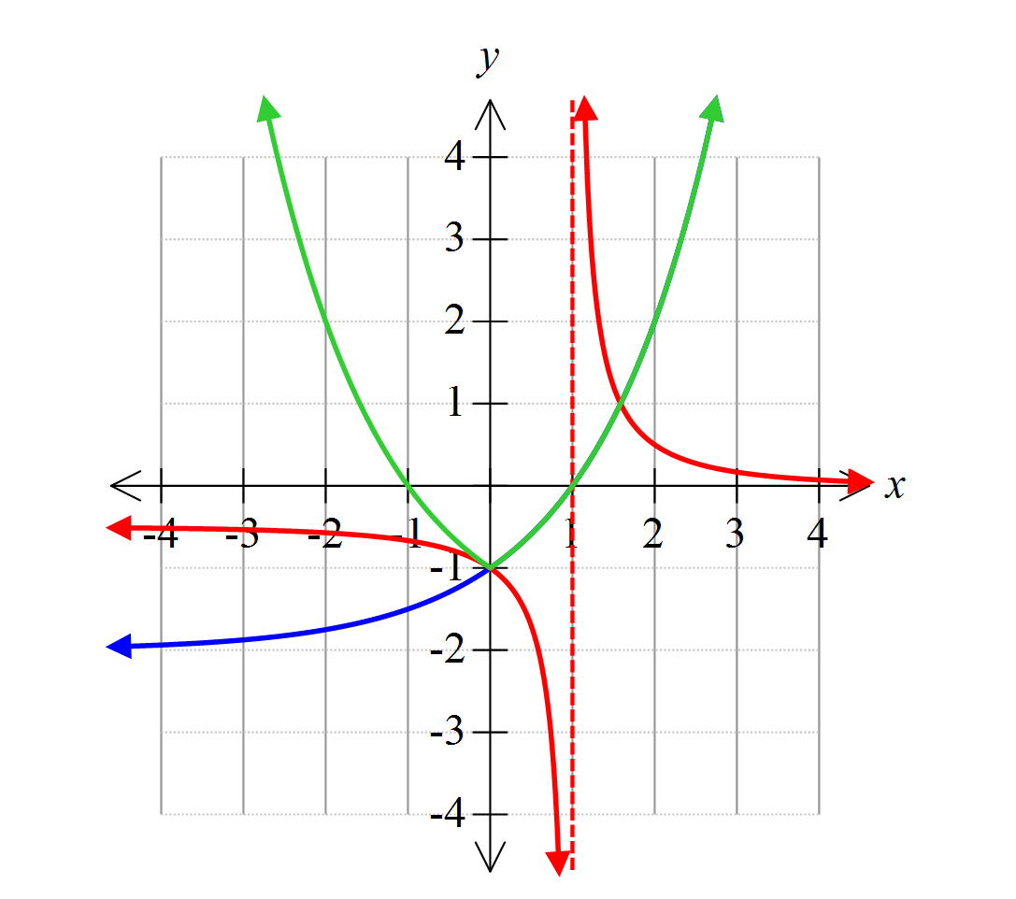

1. [7 marks]

This graph represents a function of the form 

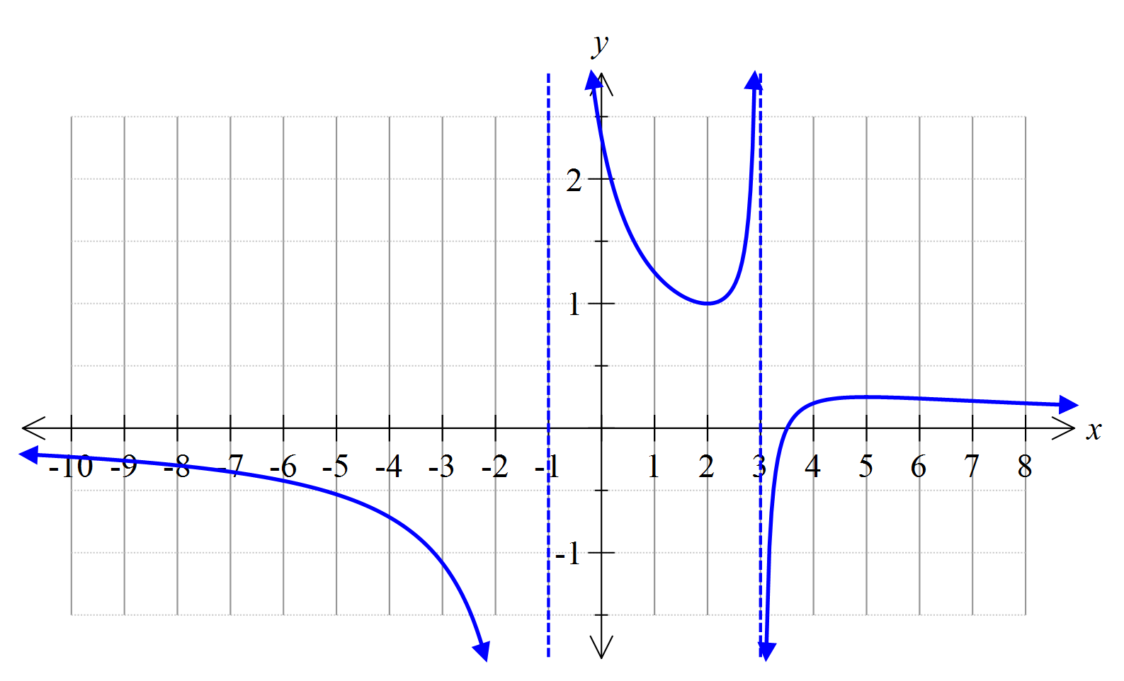

The vertical asymptotes are as shown, the *x*-intercept is (3.5, 0) and one turning point is at.

* + - * 1. Determine the values of the constants *a*, *b*, *c* and *d*.

Vertical asymptotes 







Solve simultaneously: 

[5]

* + - * 1. What is the range of ?

Other turning point is 

Range is  or 

[2]